VENDING MACHINE
CONTROLLER SIMULATOR
A Java Console-Based Project Report

Project Abstract • Objectives • Advantages • Implementation Details
Output Screenshots • Conclusion • Future Work

Prepared as a practical application of Java Modules 1–6

Student Name: Bhavya Sri
Roll Number : 2620030161

1. Project Abstract
The Vending Machine Controller Simulator is a menu-driven Java application that models the basic operation of an automated vending machine. A user can view available products, insert virtual money, select a product, complete a purchase when sufficient balance is available, receive change, and view the updated balance and inventory. The simulator also demonstrates invalid input handling and a simple restocking operation for demonstration purposes. It runs in the console and does not require physical hardware, payment services, or external libraries.
The project is designed to connect foundational Java programming concepts with a realistic problem. It uses variables and operators, conditional statements and loops, methods and arrays, object-oriented classes, exception handling, strings, file input/output, collections, and stream-based reporting. The core simulator can be implemented as a small console program; optional persistence and reporting features extend it to cover the later modules in the course.

2. Project Objectives
- Design a clear algorithm and menu flow for a vending-machine transaction.
- Apply Java syntax, primitive data types, variables, constants, operators, type conversion, and console I/O.
- Use if/else and switch selection, loops, validation, and controlled termination.
- Decompose the program into reusable methods with parameters and return values.
- Represent products and the vending machine using classes, objects, encapsulation, and constructors.
- Handle invalid product IDs, invalid numeric input, insufficient funds, and out-of-stock products safely.
- Use strings, arrays, and collections to manage product information and transaction records.
- Demonstrate file storage and stream-based summaries as optional extensions.
- Produce a maintainable, testable program that can be extended toward a more realistic vending controller.

3. Advantages
- Modular design: Methods and classes separate menu handling, payment, inventory, and reporting logic.
- Input validation: The application can reject invalid selections and prevent purchases without enough balance.
- Inventory awareness: Stock counts decrease only after a successful purchase and can be checked before dispensing.
- Easy to use: Provides a simple interface for selecting products and making payments.
- Cost-effective: No physical vending machine hardware is required.
- Inventory management: Keeps track of the quantity of available products.
- Automatic change calculation: Calculates the remaining balance and change.
- Error handling: Can identify insufficient payment and unavailable products.
- Educational: Helps students understand controllers, state transitions, and automation.
- Easy to modify: New products, prices, and features can be added easily

4. Implementation Details

4.1 System Overview
The program is a console-based simulation. The user interacts through a numbered menu. A Product object stores each product's ID, name, price, and stock quantity. The VendingMachine class owns the product collection and the current credit balance. The main application repeatedly displays the menu until the user chooses Exit.

4.2 Functional Requirements
- Display products with their IDs, prices, and remaining stock.
- Accept a positive amount of virtual money and add it to the current balance.
- Validate the selected product ID and verify that the product is in stock.
- Check the balance before completing a purchase.
- On success, deduct the price, reduce stock by one, report the dispensed item, and show remaining credit/change.
- Allow the user to inspect the balance and exit the program.
- Optionally restock products and save/load data in a future or extended implementation.

4.3 Algorithm
- Start the application and initialize the product inventory and balance to zero.
- Display the main menu.
- Read the user's menu choice and validate the input.
- If the choice is View Products, print all products and stock values.
- If the choice is Insert Money, accept a valid positive amount and update the balance.
- If the choice is Purchase, validate the product, stock, and available balance.
- If all purchase checks pass, dispense the product, deduct the price, and decrement stock.
- If the choice is View Balance, display the current balance.
- Repeat the menu until Exit is selected; then close the input resource and terminate.

4.4 Textual Flowchart
START
↓
Initialize products and balance
↓
Display menu and read choice
↓
Choice = Exit? ── Yes ──→ END
│ No
↓
Perform selected action
↓
Validate input / product / stock / balance
↓
Update balance and inventory only if valid
↓
Display result and return to menu

4.5 Course Module Mapping
Module 1 — From Problem to Program: Computational Thinking & Java Foundations
Problem decomposition, algorithm and flowchart, Java program structure, identifiers, literals, variables, constants, primitive types, operators, type casting where needed, precedence, Scanner input, and formatted output.
Module 2 — Control Flow: Selection & Iteration
A switch statement routes menu actions; if/else checks validity, stock, and balance; a while loop keeps the session active; break/continue may be used for menu control and invalid entries.
Module 3 — Decomposition with Methods, Recursion & Arrays
Methods such as displayProducts(), insertMoney(), purchaseProduct(), and showBalance() separate responsibilities. Arrays or collection traversals can calculate stock totals, product averages, and searches. Recursion is not required for the core use case but can be demonstrated in an optional menu-tree or retry exercise.

Module 4 — Object-Oriented Modelling, Design & Exception Handling
Product and VendingMachine classes model domain objects. Private fields and getters/setters support encapsulation. Constructors initialize objects; static final constants define fixed values; toString() supports readable product output. try/catch handles invalid input and exceptional cases.
Module 5 — Strings, Library Algorithms & File I/O
Product names and menu messages use String operations. equals() should be used for text value comparison. Optional CSV persistence can use Path and Files, buffered reading/writing, split(), trimming, and try-with-resources. Arrays.sort() or Comparator can sort products.
Module 6 — Functional Programming with Collections & Streams
A List<Product> or Map<Integer, Product> stores products safely with generics. Lambdas and streams can filter low-stock items, sort products, count transactions, group sales, and produce a concise inventory report.

4.6 Suggested Class Design
Class / Component | Main Data | Responsibilities
Product | id, name, price, stock | Store product details; check availability; reduce or increase stock.
VendingMachine | products, balance | List products; accept credit; validate and complete purchases.
VendingMachineApp | Scanner / menu loop | Read console input, call machine methods, handle menu choices.
Transaction (optional) | product ID, amount, timestamp | Record purchases and support history/reporting.

4.7 Testing Plan
Test Case | Input / Condition | Expected Result
Display inventory | Choose menu option 1 | All product IDs, prices, and stock values appear.
Valid payment | Insert Rs. 50 | Balance increases by Rs. 50.
Successful purchase | Balance Rs. 50; buy Chips at Rs. 30 | Chips dispensed, stock decreases by one, balance becomes Rs. 20.
Insufficient balance | Balance Rs. 10; buy Chocolate at Rs. 25 | Purchase rejected; stock and balance remain unchanged.
Invalid product | Enter product ID 99 | Error message; no inventory change.
Invalid numeric input | Enter letters at a numeric prompt | Input error shown; program continues.
Invalid payment | Insert zero or a negative amount | Amount rejected; balance unchanged.
Exit | Choose option 0 | Session ends cleanly.

5. Output Screenshots
The screenshots below are illustrative console-output mockups showing expected behavior for the documented scenario. They are report visuals, not captures from an executed Java runtime. When submitting a tested build, replace them with genuine screenshots from your IDE or terminal.

Figure 1. Main menu and product inventory
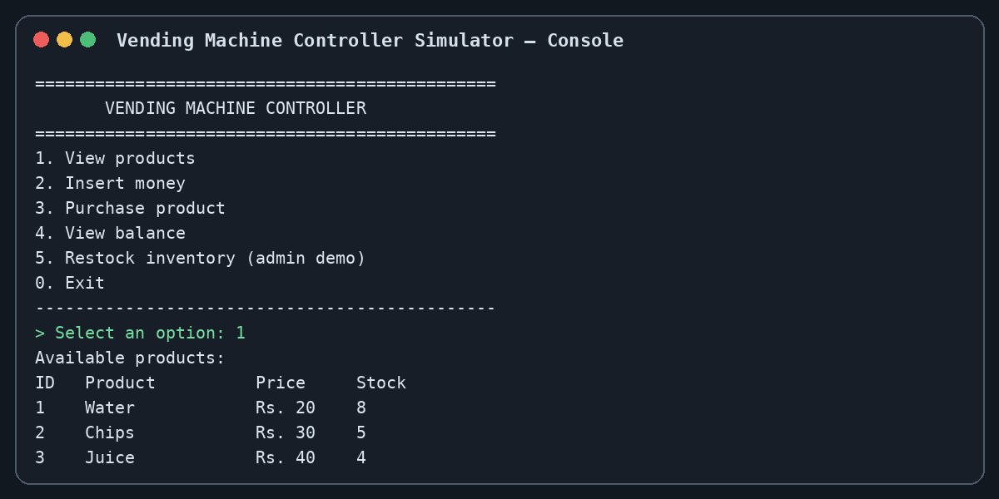

Figure 2. Successful purchase and change
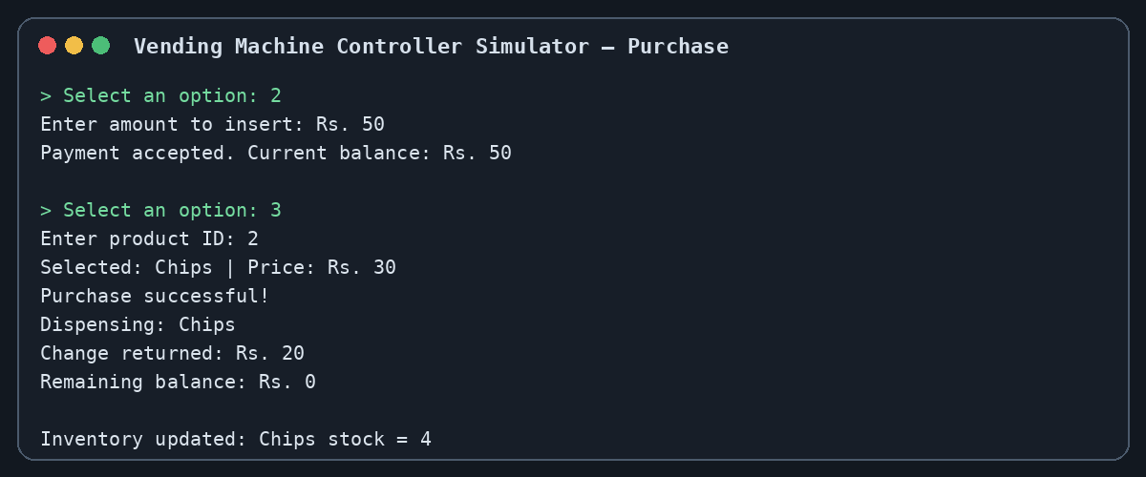

Figure 3. Validation: insufficient balance and invalid ID
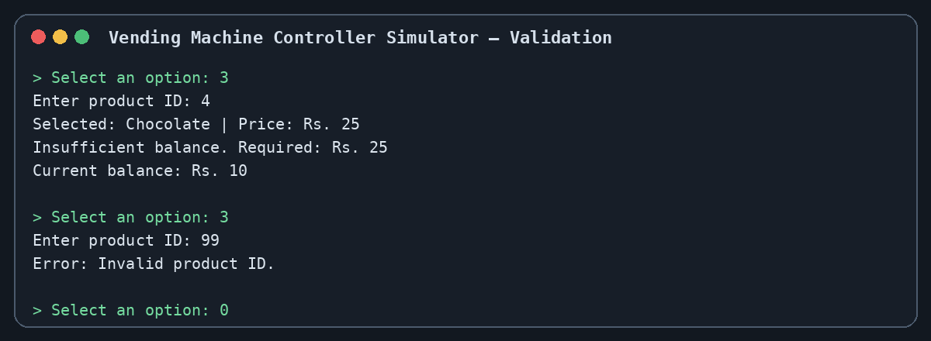
Output 1 – Main Menu
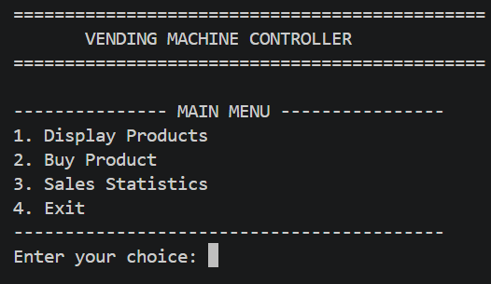

Output 2 – Display Products
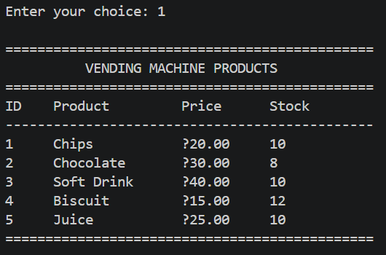
Output 3 – Successful Purchase
Example: User selects Chocolate and enters ₹50.
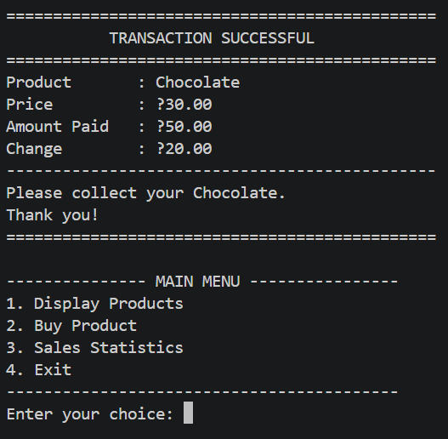

Output 4 – Insufficient Payment
Example: Soft Drink costs ₹40 and the user initially enters ₹10.
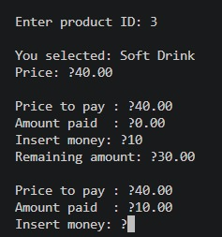
Then:
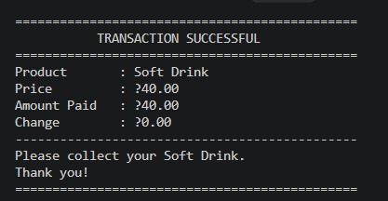

Output 5 – Invalid Payment
If the user enters 0 or a negative amount:
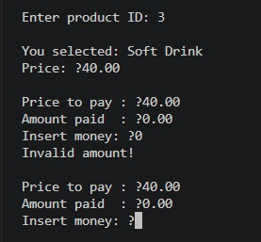
Output 6 – Invalid Product ID
If the user enters a product number that doesn't exist:
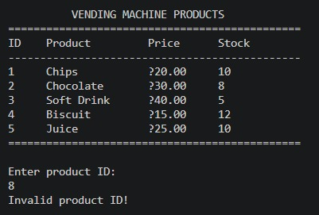

Output 7 – Out of Stock
If a product's stock becomes zero:
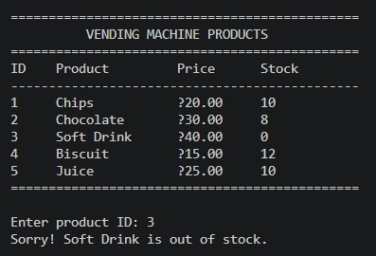

Output 8 – Sales Statistics
After some purchases:
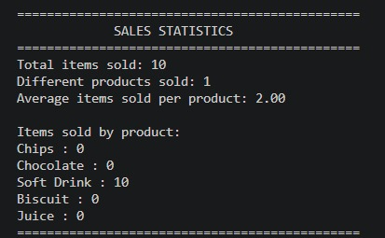

6. Conclusion
The Vending Machine Controller Simulator demonstrates how a practical problem can be translated into an algorithm and implemented with Java. It combines console interaction, control flow, reusable methods, arrays, object-oriented design, and exception handling in one coherent application. The purchase workflow validates the product, availability, and balance before updating the inventory, helping maintain consistent state. The modular design also provides a foundation for adding persistent storage, richer reporting, and a graphical interface. Overall, the project is suitable as a learning exercise for the six modules because each concept can be tied to a visible behavior in the program.

7. Future Work
- Add real-time inventory monitoring.
- Integrate QR-code and digital payments.
- Add a database Add for storing products and transactions.
- Implement administrator login for managing inventory and prices.
- Add receipt generation.
- Add physical motors and sensors for actual product dispensing.
- Implement remote monitoring of machine status.
- Add sales reports and transaction history.
- Improve the user interface with touchscreen-style controls
- Transaction receipts: Record timestamp, product, price, amount paid, and change in a transaction log.
- Automated tests: Add unit tests for stock changes, balance updates, invalid IDs, and edge cases.
- Graphical interface: Build a Java Swing or JavaFX interface with product cards, balance display, and status messages.

